Recruiter management questions and questionnaires
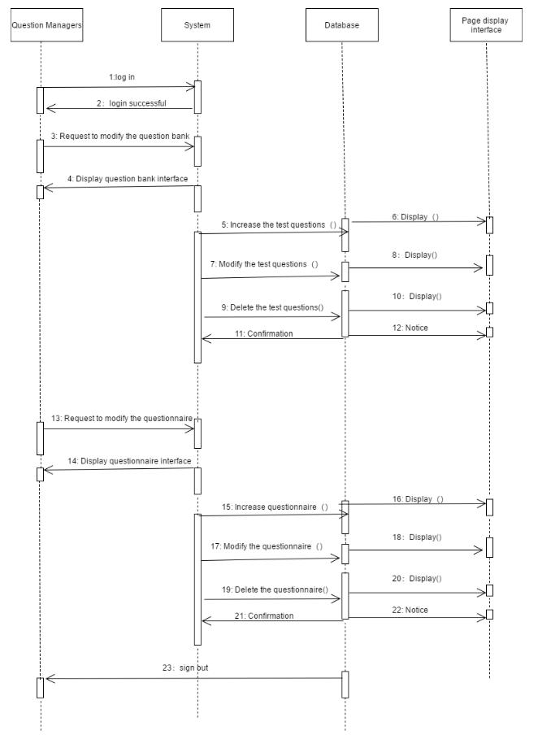

Recruiters post jobs
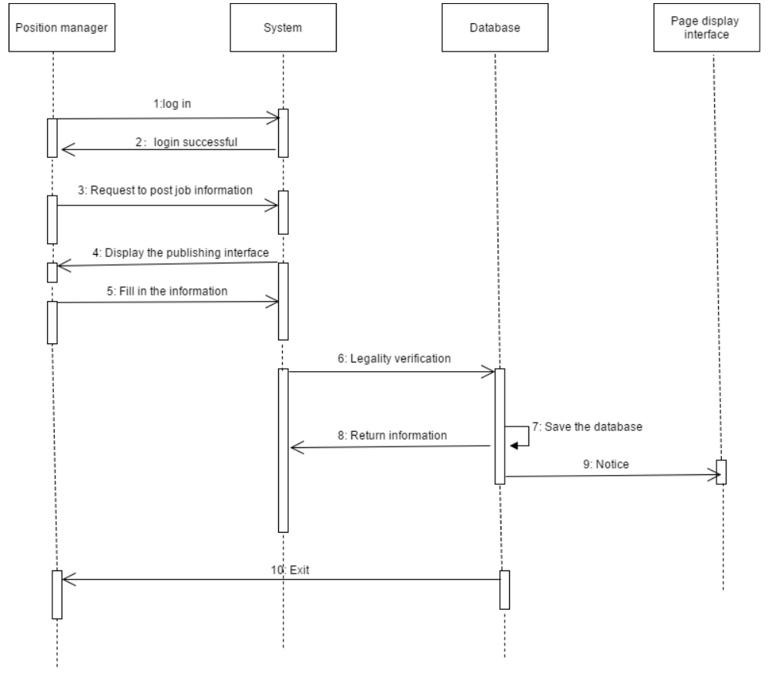
- Class Diagram
a Entity class
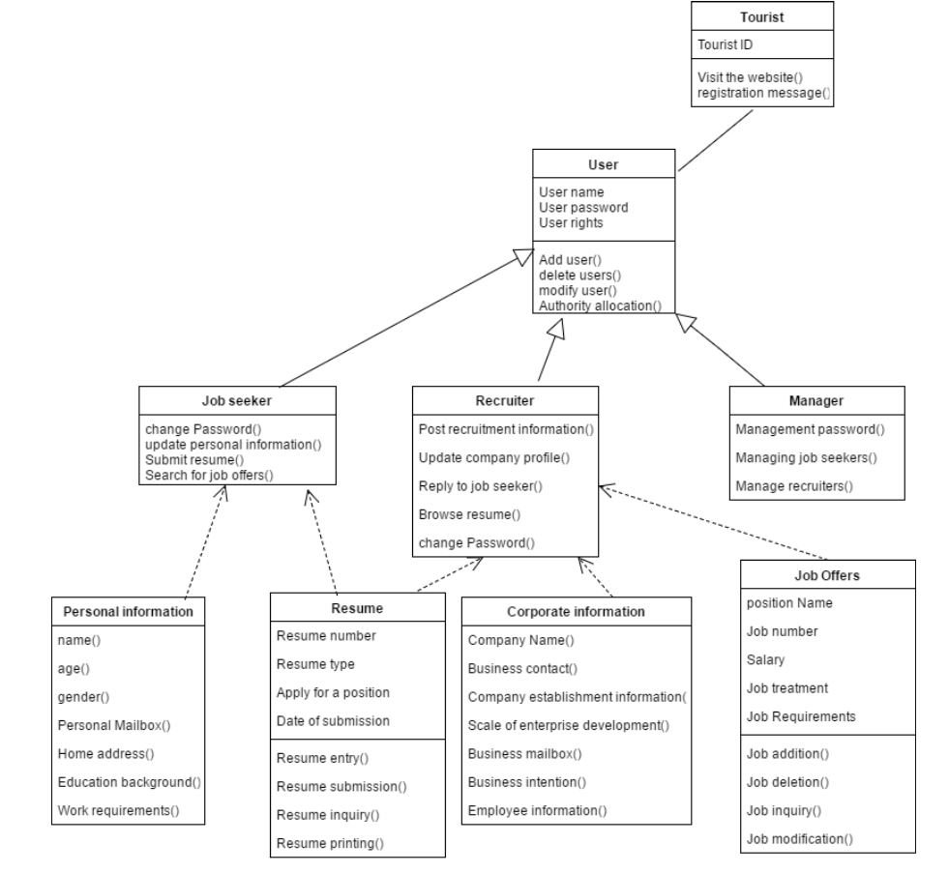

b Interface class

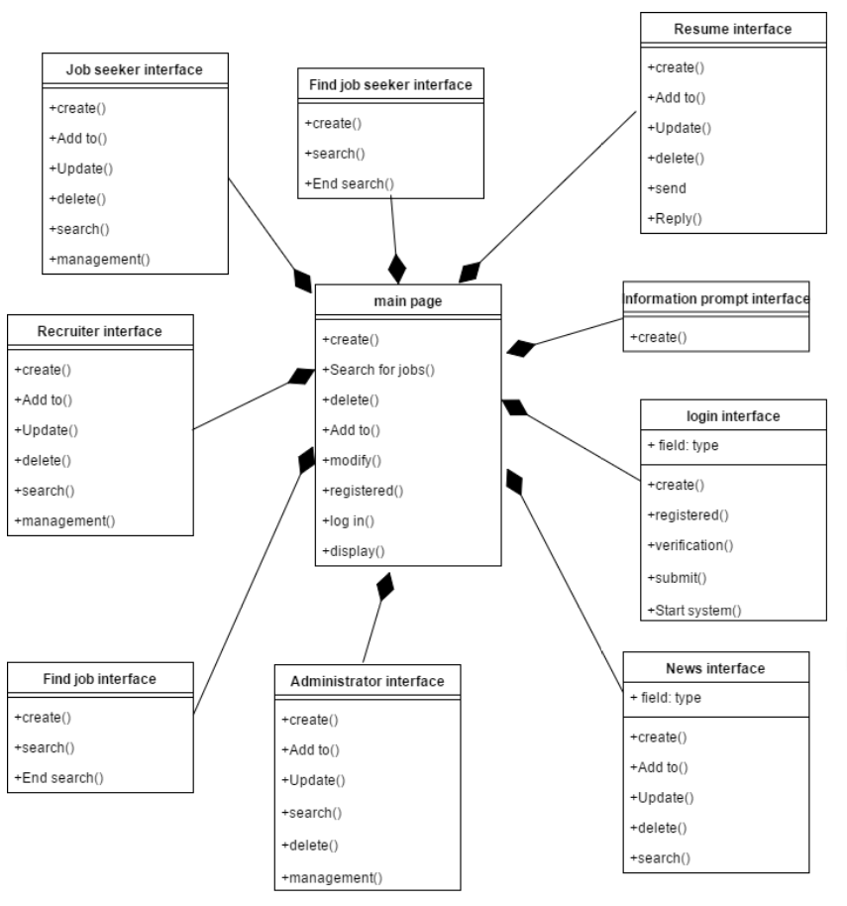

- Data Types and Operation Signatures
A. Visitor
Class Name: Visitor
Attribute: Visitor ID
Operation: Visit the website (), registration message()
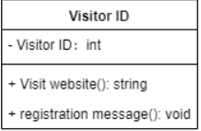
B. user
Class name: user
Attributes: username, user password, user rights
Action: Add user (), delete user (), modify user (), Authority allocation()
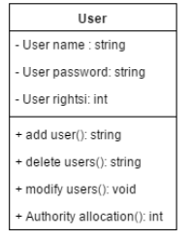
C. job seeker
Class name: job seeker
Operation: Change password (), update personal information (), submit resume (), search for job offers ()
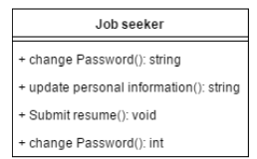
D. Recruiter
Class Name: Recruiter
Operation: post the recruitment information (), update the company information (), reply to the job seeker (), browse the obtained resume (), change the password ()
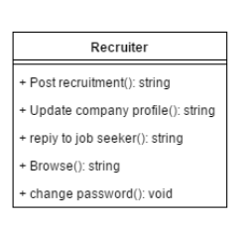
E. Manager
Class name: manager
Operation: Manage Passwords (), Manage Job Applicants (), Manage Recruiters ()
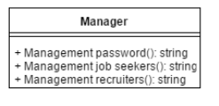

F. Personal information
Class name: personal information
Attributes: name, age, gender, personal email address, home address, educational background, job requirements
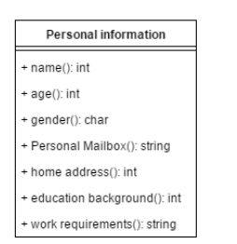
G. resume
Class name: resume
Attributes: resume number, resume type, application position, submission date
Operation: Resume entry (), resume submission (), resume inquiry (), resume print ()
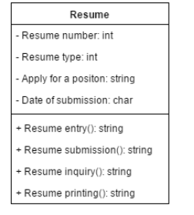
H. Corporate information
Class Name: Corporate Information
Attributes: company name, company contact information, company establishment information, enterprise development scale, enterprise mailbox, enterprise employer intention, enterprise employee information
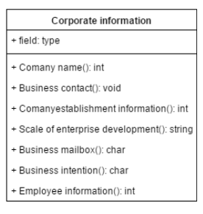
I. Job Offers
Class Name: Recruitment Information
Attributes: job title, job number, salary, position treatment, job requirements
Operation: Job Add (), Job Delete (), Job Query (), Job Edit ()
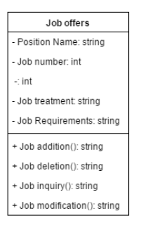
J. Main interface
Class name: main interface
Action: Create (), search for posts (), delete (), add (), modify (), register (), login (), display ()
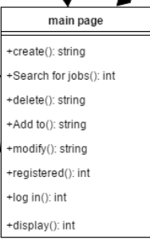

K. Login interface
Class name: login interface
Action: create (), register (), verify (), submit (), start the system ()
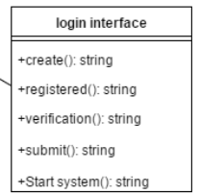
L. Information prompt interface
Class name: information prompt interface
Action: Create ()
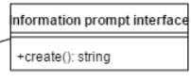
M. Resume interface
Class name: resume interface
Action: create (), add (), update (), delete (), send (), reply ()
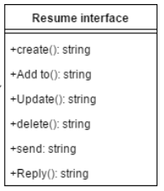
N. Find job seeker interface
Class Name: Find job seeker interface
Action: create (), find (), end the search ()
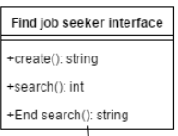
O. Job seeker interface
Class Name: Job Applicant Interface
Action: Create (), add (), update (), delete (), find (), manage ()
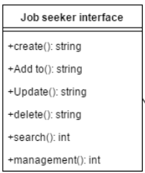
P. Recruiter interface
Class Name: Recruiter Interface
Action: Create (), add (), update (), delete (), find (), manage ()
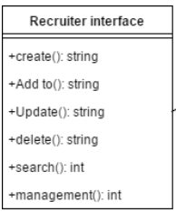
Q. Find job interface
Class name: find job interface
Action: Create (), find (), end the search ()
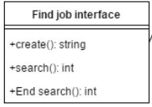
R. Administrator interface
Class name: administrator interface
Action: Create (), add (), update (), find (), delete (), manage ()
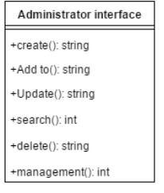
S. News interface
Class name: news interface
Action: create (), add (), update (), delete (), find ()
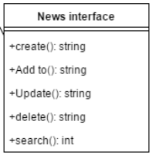
.Persistent Data Storage
In our system, data such as personnel information, company information, interview information, etc. need to be stored persistently.
Persistent data should be stored in files, relational databases and object-oriented databases
There are six tables in our system database.
- User table
Store user information
- Role table
Whether the identity is a corporate user or a normal user and administrator
- Resume table
Store the user's resume information according to the user ID
- Company table
Store company information
- Recruitment information table
Store job postings from company users
- Job information table
Store job information for users to send resumes

